Nepal College of Information Technology
Unit Test
Fall 2009

Program: BE Time: 2 hrs
Semester: Fall FM: 60
Subject: Engineering Math-III PM: 30
Attempt ALL the questions. Figures at the margin indicate their full marks.

1. a) Prove that 7
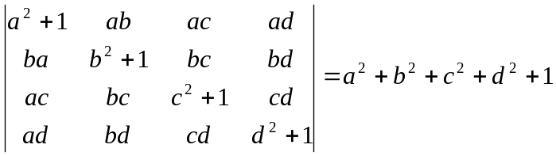
OR
Prove that
(AB)⁻¹ = B⁻¹ A⁻¹

b) Solve by Gauss elimination method 8
10x + 4y - 2z= -4
-3w - 17x + y + 2z = 2
w +x + y = 6
8w - 34x + 16y - 10z = 4

2. a) Define rank of the matrix. Find the rank of the matrix
A = 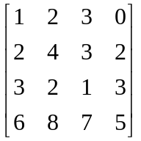 5+2
b) Check the consistency of the following equations and solve 8
x + 2y - z = 3
3x - y + z = 1
2x - 2y + 3z = 2
x - y + z = -1

3. a) Let
V = R³ be a vector space
Let W₁ ₌ 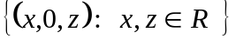
W₂ = 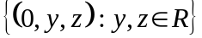
Show that
W₁, W₂, W₁ W₂ are subspace of V 8

b) Prove that the necessary and sufficient condition for the vector-valued function of the scalar variable t to have a constant direction is 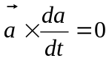 7

4. a) Find the angle between the surface x² + y² + z² = 9 and z = x² + y² -3 at the pint (2,1,-2) 8

b) Define divergence and curl of a vector function. Find divergence and curl of 7

